**Lab # 10**

**OBJECT**

***Configure Syslog, NTP Server***

**TOPOLOGY:**

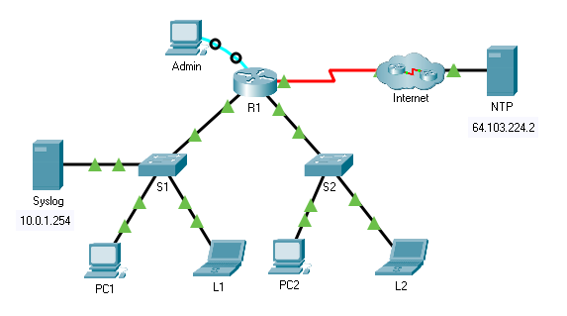

**LAB TASK:**

**Part 1: Configure Syslog Service**

**Part 2: Generate Logged Events**

**Part 3: Manually Set Switch Clocks**

**Part 4: Configure NTP Service**

**Part 5: Verify Timestamped Logs**

**Part 1: Configure Syslog Service**

a. Configure secure remote access for the router. You will remote access the devices to enable and use the Syslog service and the NTP service so that the network administrator is able to monitor the network more effectively.



b. Configure the hostname as (Your name)-Router.



c. In this part, you will access the router R1 via the console port to configure secure remote access SSH. The privileged EXEC password for all the network devices is cisco12345.

d. Set a domain name of your choice on R1.Create a user of your choice with a strong encrypted password.Generate 1024-bit RSA keys.Configure all vty lines for SSH access and use the local user profiles for authentication.Set the EXEC mode timeout to 5 minutes on the vty lines.Block anyone for five minutes who fails to log in after four attempts within a two-minute period.

R1(config)# login block-for 600 attempts 4 within 120 .

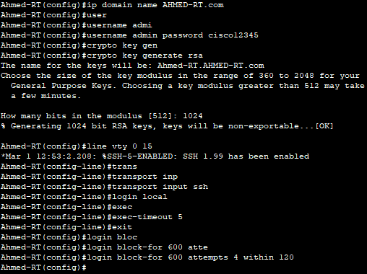

e. Click Syslog, then Services tab.Turn the Syslog service on and move the window so you can monitor activity.

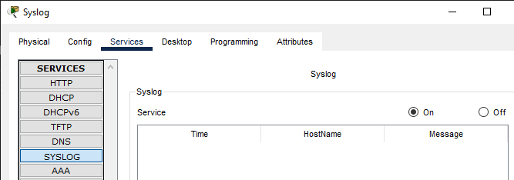

f. Configure the intermediary devices to use the Syslog service.

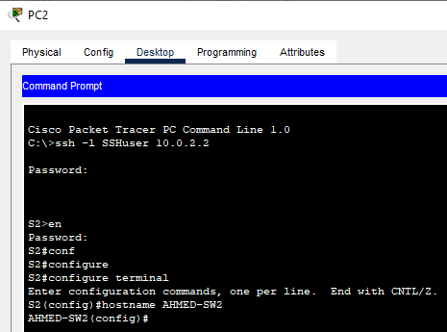

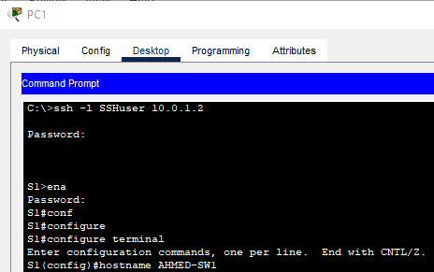

g. From the remote SSH session, configure R1 to send log events to the Syslog server.

R1(config)# logging 10.0.1.254



From the remote SSH session, configure S1 to send log events to the Syslog server.

S1(config)# logging 10.0.1.254



From the remote SSH session, configure S2 to send log events to the Syslog server.

S2(config)# logging 10.0.1.254



**Part 2: Generate Logged Events**

a. Change the status of interfaces to create event logs. Within the established SSH session, configure a Loopback 0 interface on R1 then disable it.

R1(config)# interface loopback 0

R1(config-if)# shutdown

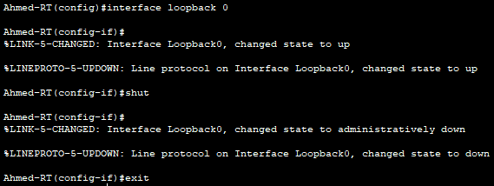

b. Turn off PC1 and PC2. Turn them on again.

c. Examine the Syslog events. Look at the Syslog events. Note: All the events have been recorded; however, the time stamps are incorrect. You may need to click inside the cells to see the messages

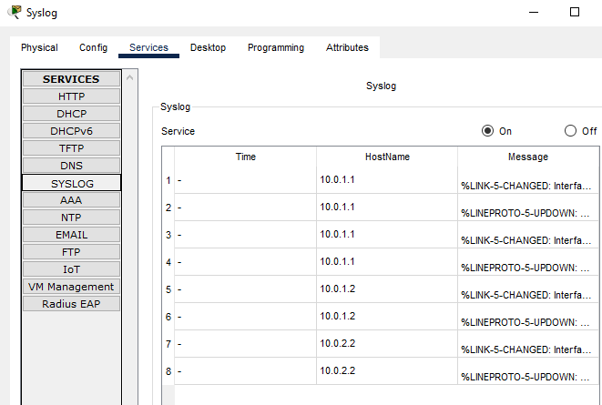

**d.** Clear the log before proceeding to the next part.

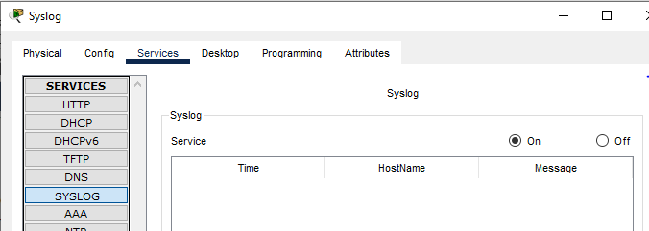

**Part 3: Manually Set Switch Clocks**

a. View the date and time on the switches. After the PCs have finished reloading, establish the SSH sessions to the network devices again as necessary.

Switch 1:



Switch 2:



b. Attach the screenshot of the web browser of PC 1, 2 showing that its obtaining the

hostname Yahoo.com. View the current time set on the clock.

PC0:



PC1:



c. Manually set the clocks on the switches. From the established SSH session, manually set the clock on S1 and S2 to the current date and approximate time. An example is provided.

Switch 1:



Switch 2:



d. Enable the logging timestamp service on the switches. Configure S1 and S2 to send its timestamp with logs it sends to the Syslog server via the established SSH session.

S1(config)# service timestamps log datetime msec



S2(config)# service timestamps log datetime msec



**Part 4: Configure NTP Service**

a. Enable the NTP service.In this activity, we are assuming that the NTP service is being hosted on a public internet server. If the NTP server was private, authentication could also be used.

b. Open the Services tab of the NTP server. Turn the NTP service on and note the date and time that is displayed.

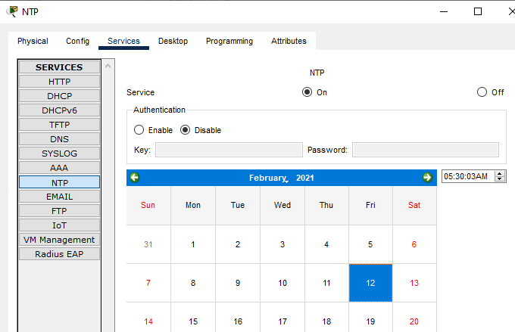

c. Automatically set the clock on the router. Set the clock on R1 to the date and time according to the NTP server.

R1(config)# ntp server 64.103.224.2



d. Enable the logging timestamp service of the router. Configure R1 to send its timestamp with the logs that it sends to the Syslog server.

R1(config)# service timestamps log datetime msec



**Part 5: Verify Timestamped Logs**

a. Change the status of interfaces to create event logs.



b. Re-enable and then disable the Loopback 0 interface on R1.

R1(config)# interface loopback 0

R1(config-if)# no shutdown

R1(config-if)# shutdown

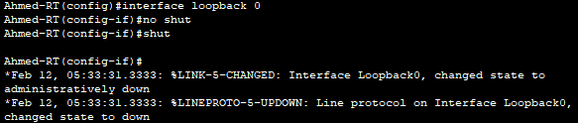

c. Turn off laptops L1 and L2. Turn them on again.

d. Examine the Syslog events. Look at the Syslog events. Note: All the events have been recorded and the time stamps are correct as configured. Note: R1 uses the clock settings from the NTP server, and S1 and S2 use the clock settings configured in an earlier part of this activity.

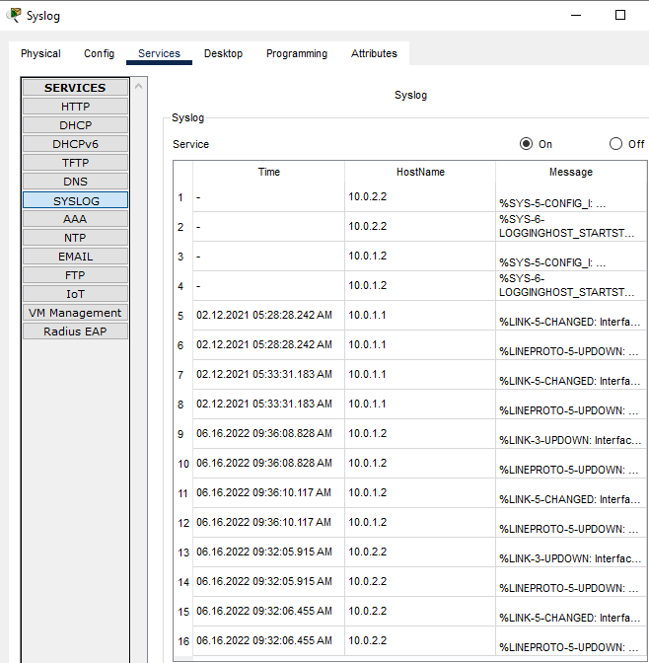

**Part 4: Set up Router as a DHCP-server for dynamically assigning IP Addresses**

a. Attach the screenshot of the Routers DHCP Server configuration. Use the DHCP

pool name as SSUET.

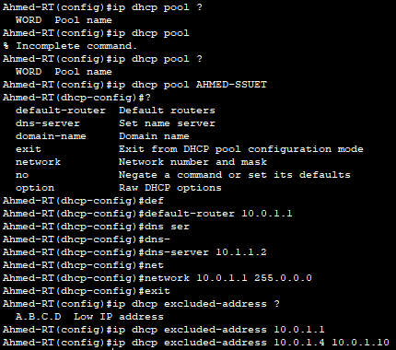

b. Attach the screenshot of the PC 1, 2 showing that its obtaining the IP address

dynamically.

PC 1:

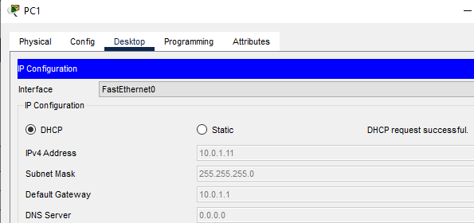

PC 2:

